***CSA1002:-SOFTWARE ENGINEERING WITH DATA ANALYTICS***

***Name: RAKESH.R***

***Reg.no: 192121121***

***1)* Draw a USE-CASE diagram for Online Voting System using CASE tools**

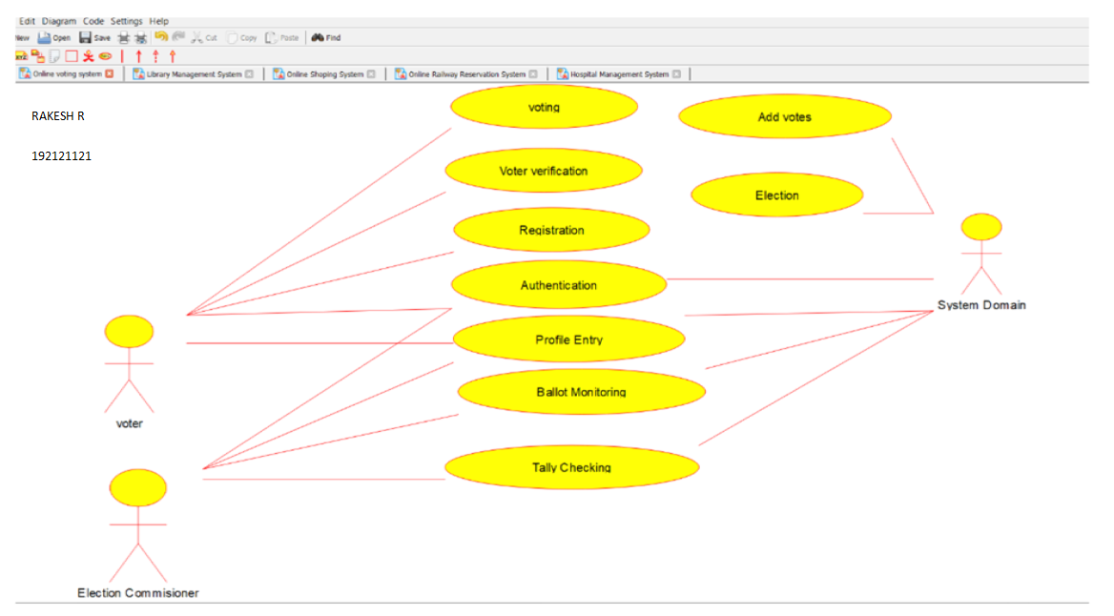

**2Q. Draw a USE-CASE diagram for Library Management System using CASE tools.**

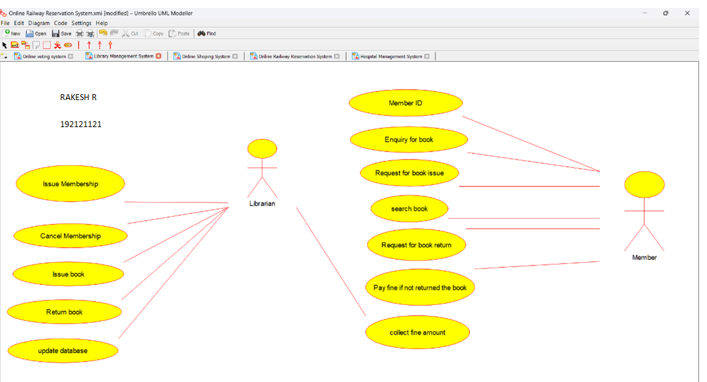

**3Q. Draw and validate the flowchart to compute the quotient and remainder.**

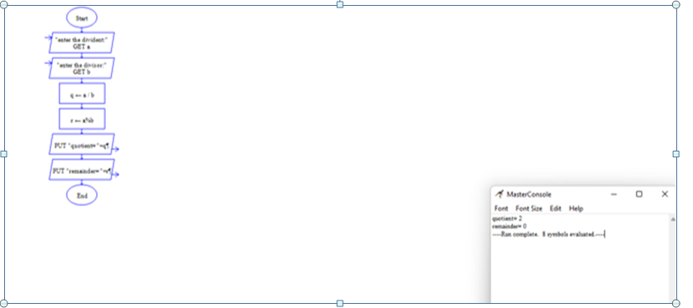

**4. Draw a USE-CASE diagram for Online Shopping system using CASE tools.**

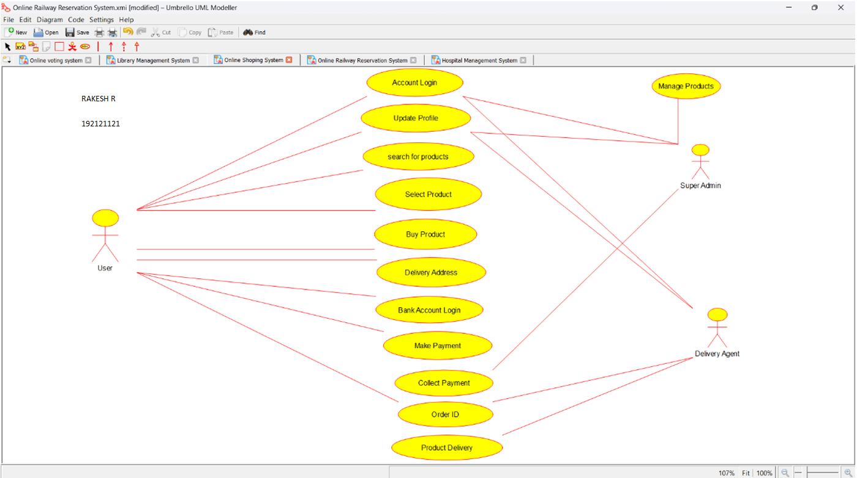

**5Q. Draw a USE-CASE diagram for Online Railway Reservation System using CASE tools.**

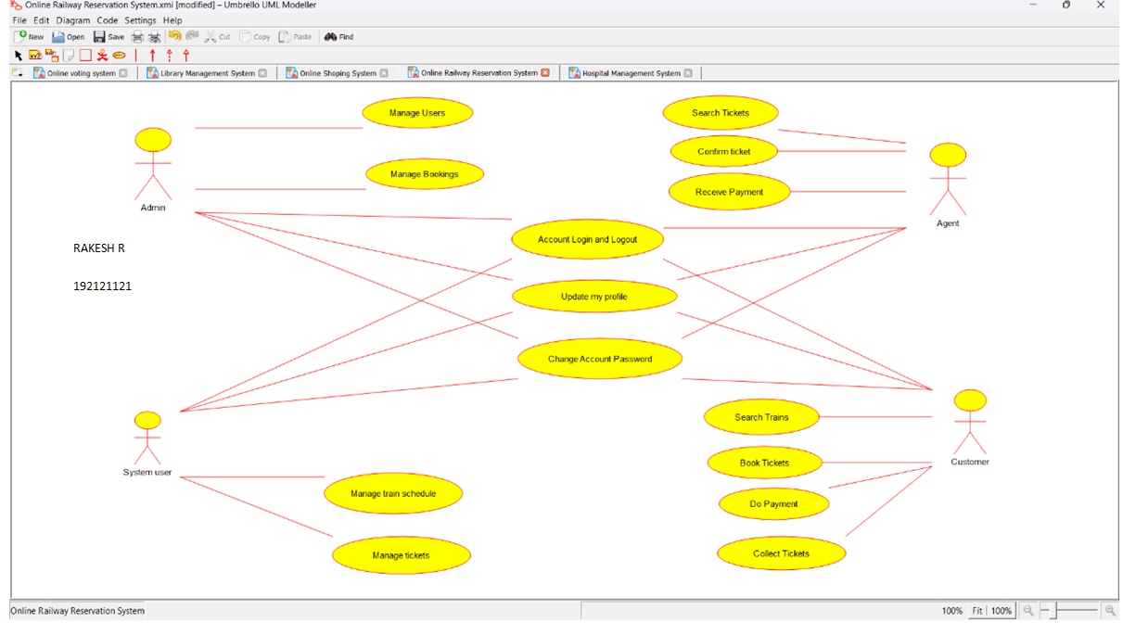

**6Q. Draw a USE-CASE diagram for Hospital Management System using CASE tools.**

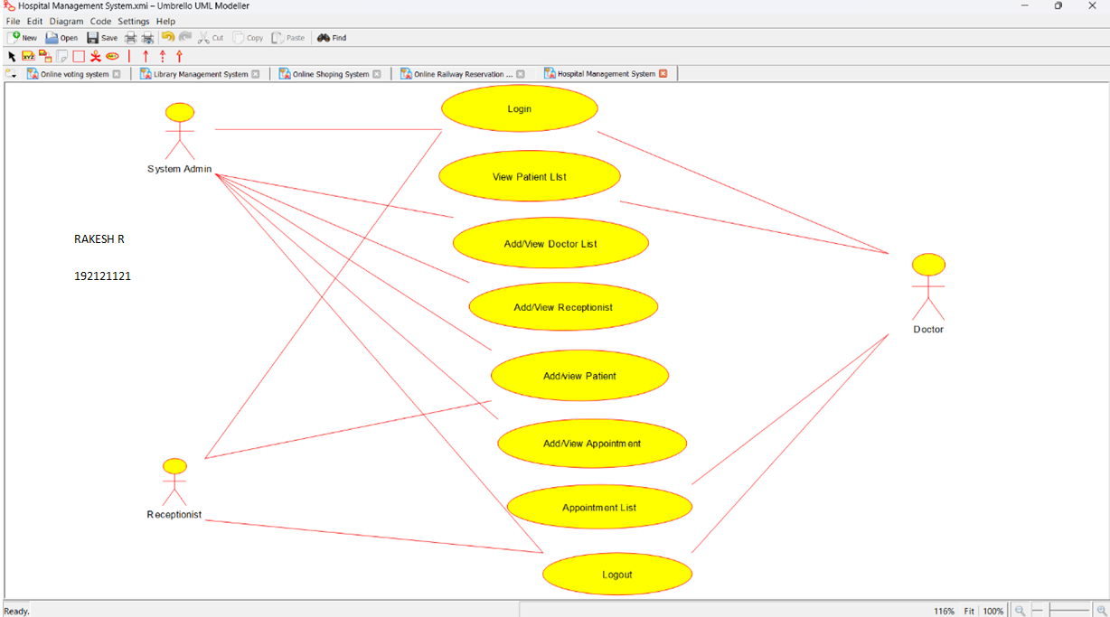

**7Q. Draw a USE-CASE diagram for ATM System using CASE tools.**

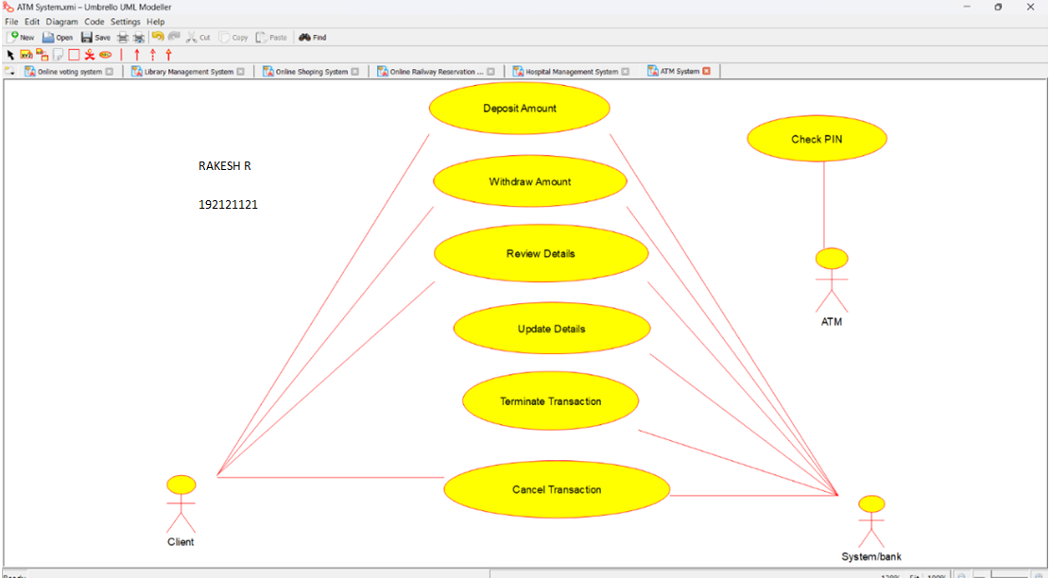

**8Q. Draw a USE-CASE diagram for Online college management System using CASE tools.**

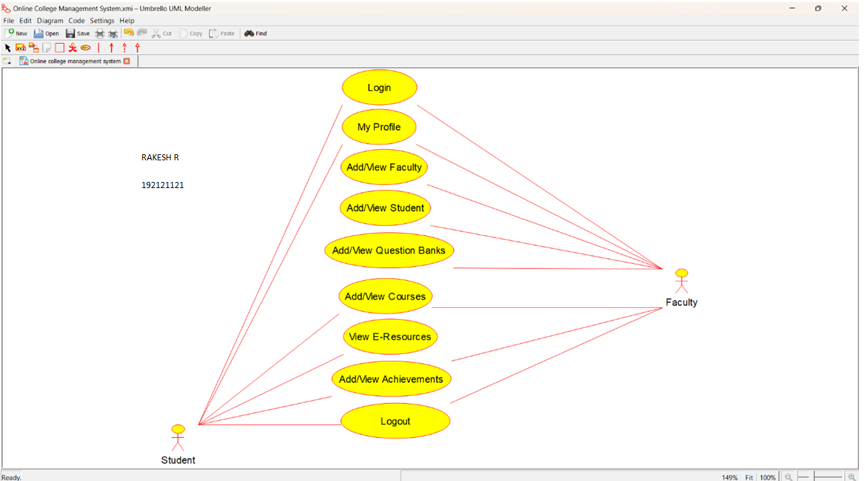

**9Q. Draw a USE-CASE diagram for Online Airline Reservation System using CASE tools.**

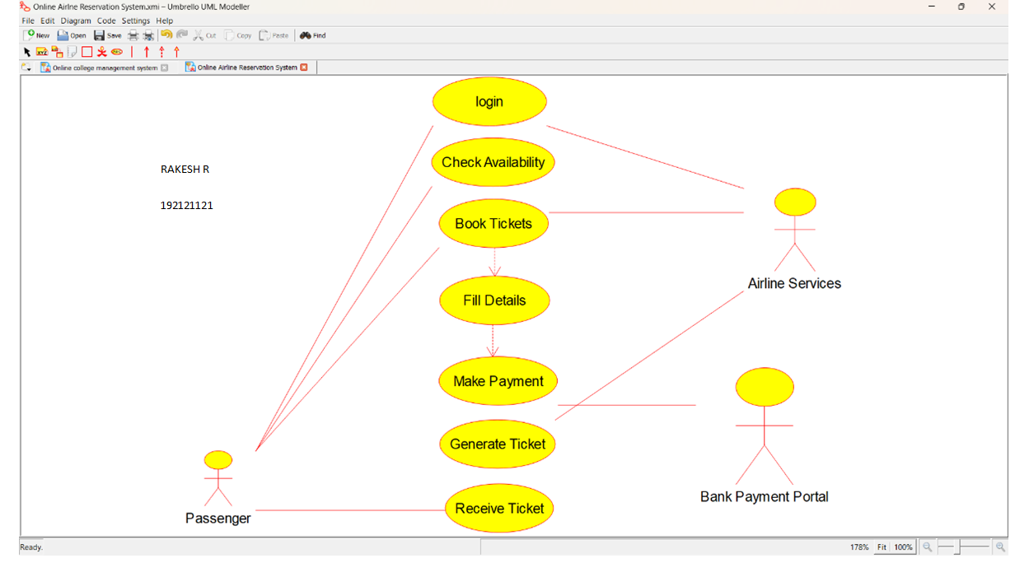

**10Q. Draw a Class diagram for Online Airline Reservation System**

**using CASE tools.**

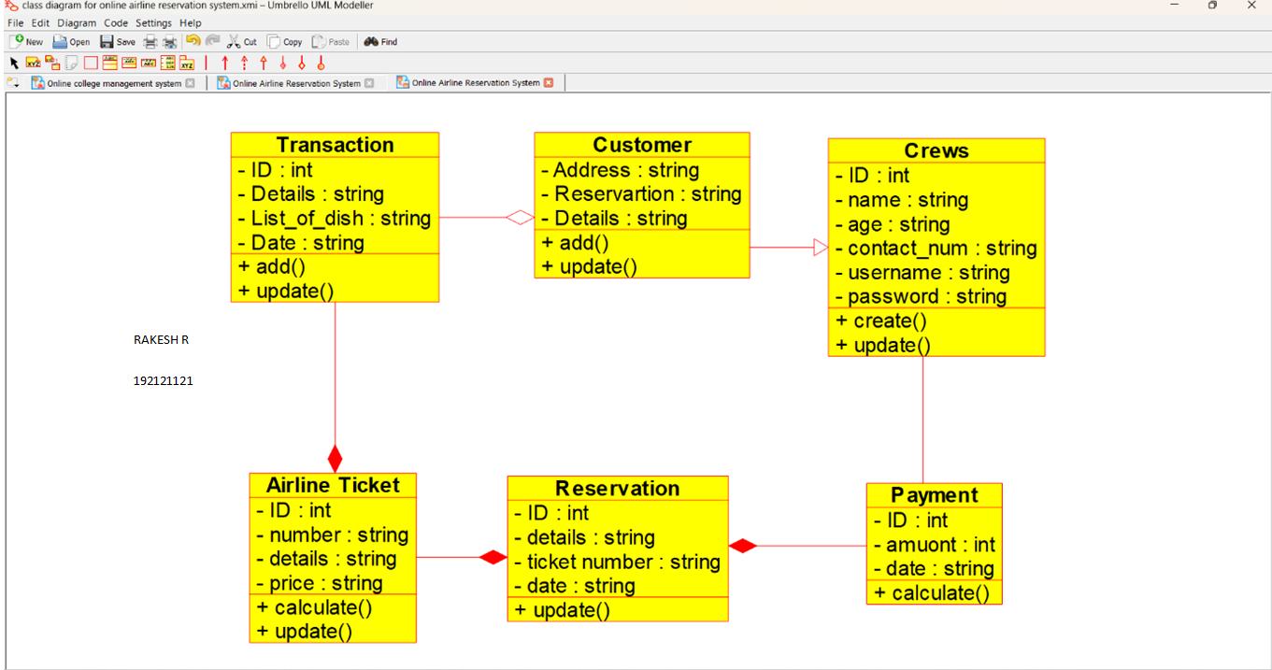

**11Q. Draw a Class diagram for Online Voting System using CASE tools**

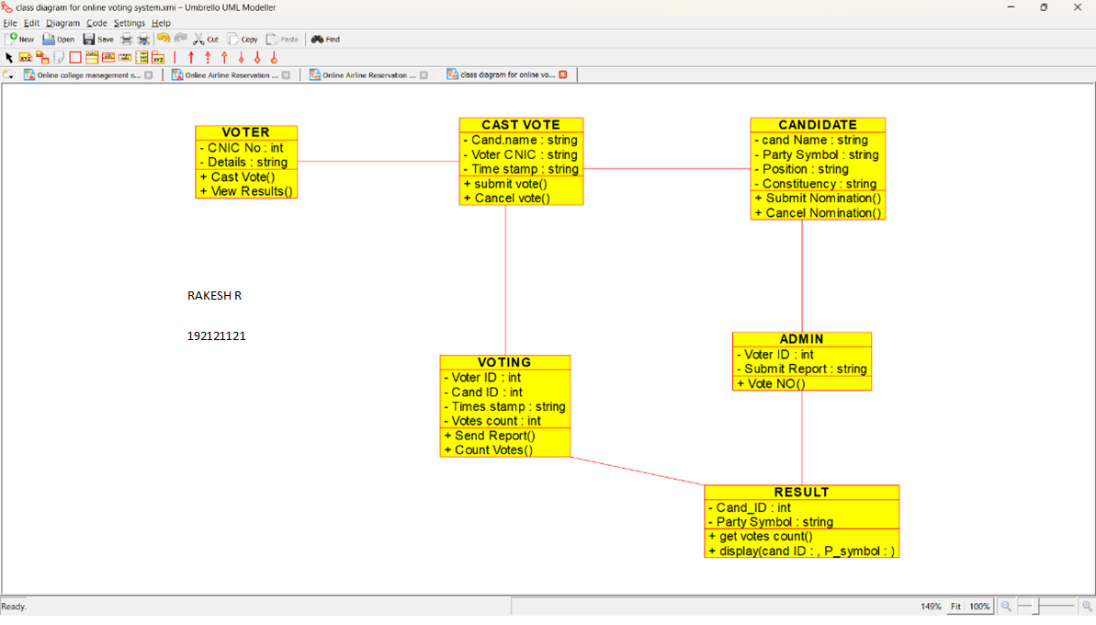

**12Q. Draw a Class diagram for Library Management System using CASE tools.**

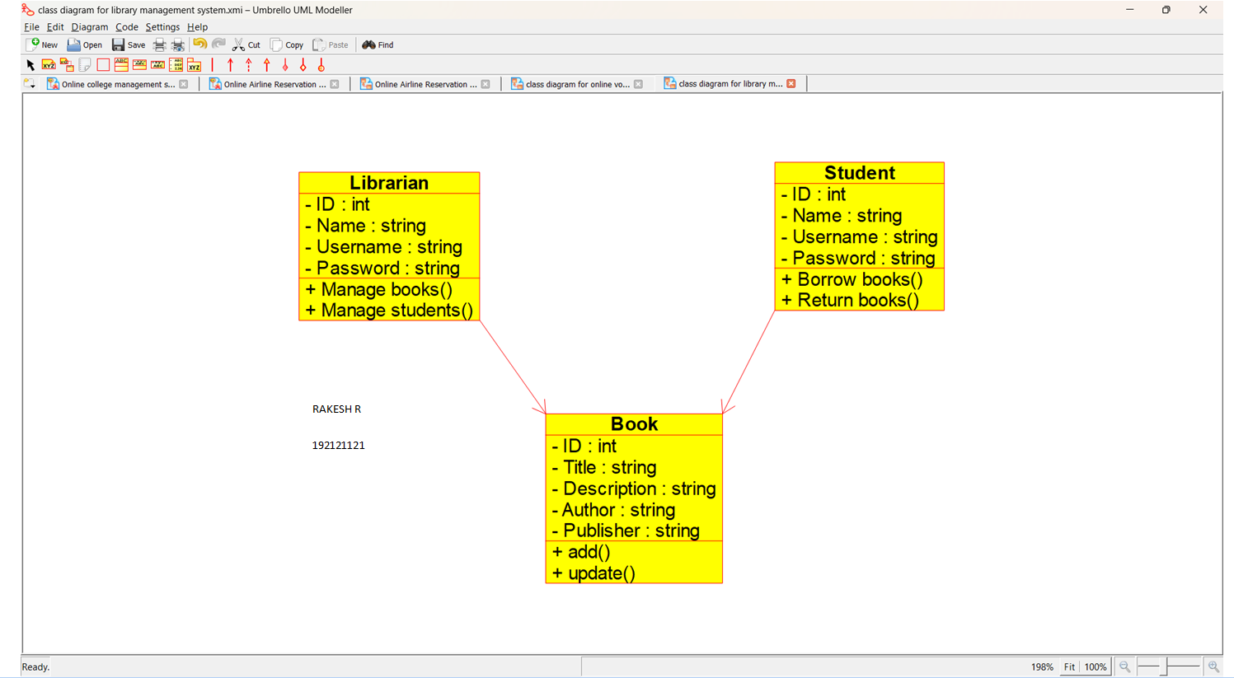

**13. Draw a Class diagram for Online Shopping system using CASE tools.**

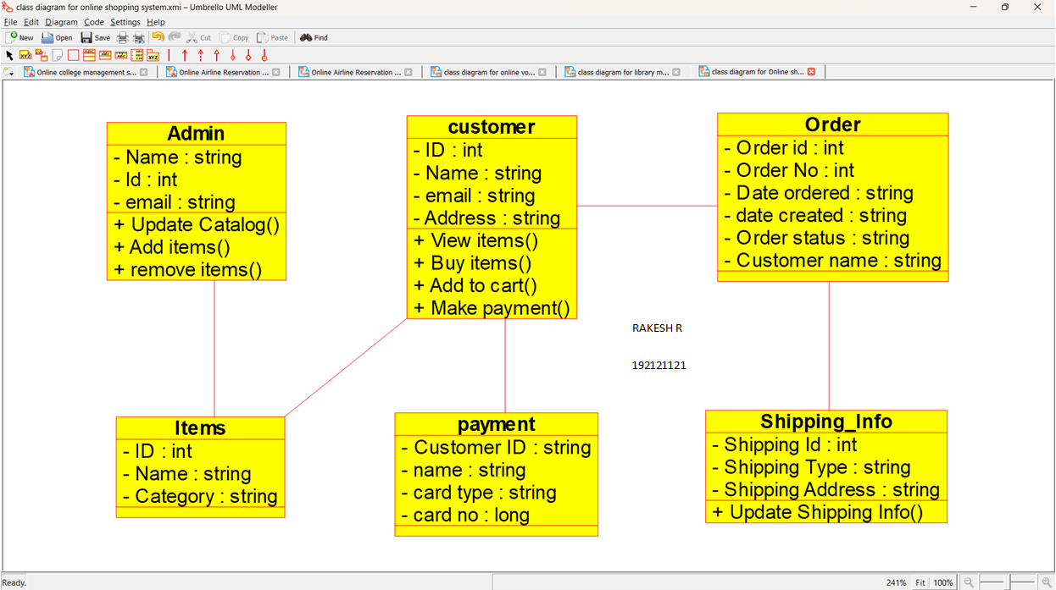

**14Q. Draw a Class diagram for Online Railway Reservation System using CASE tools.**

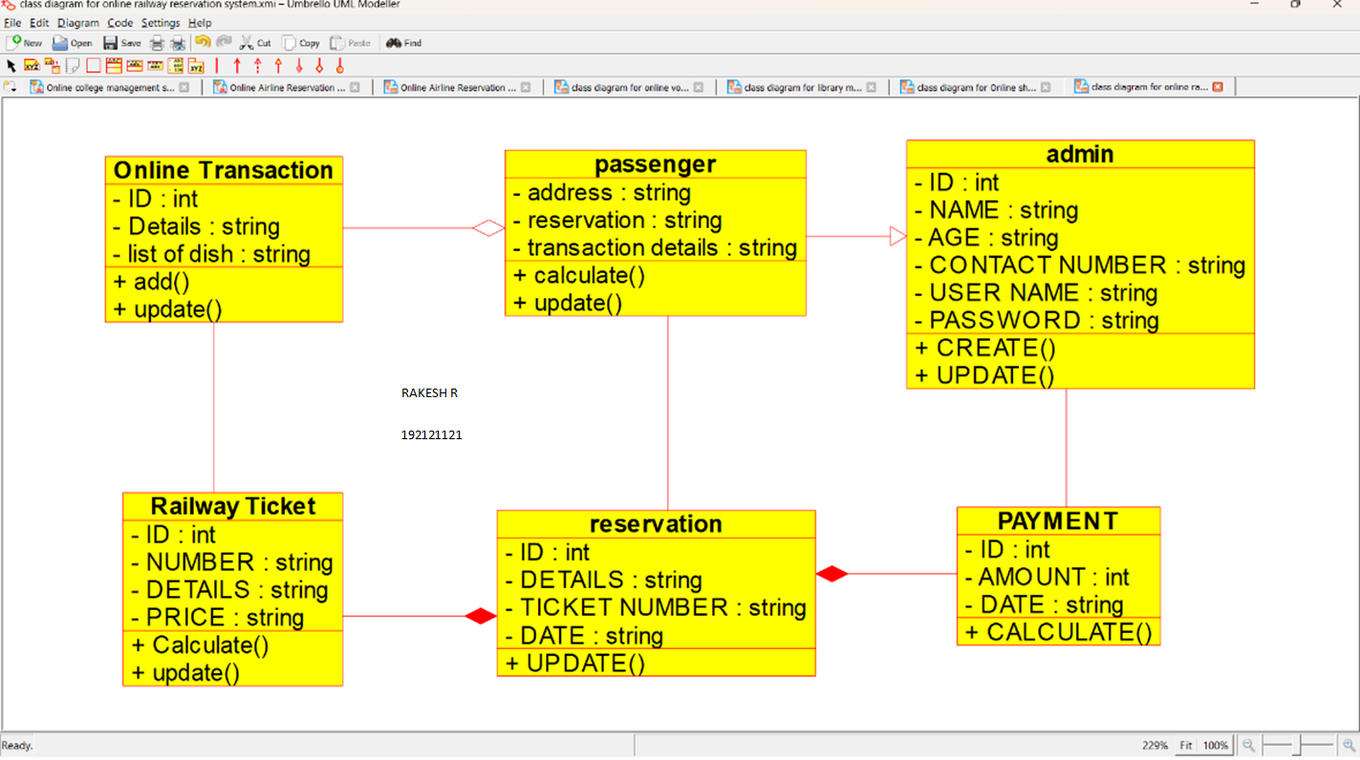

**15Q. Draw a Activity diagram for Online Voting System using CASE tools.**

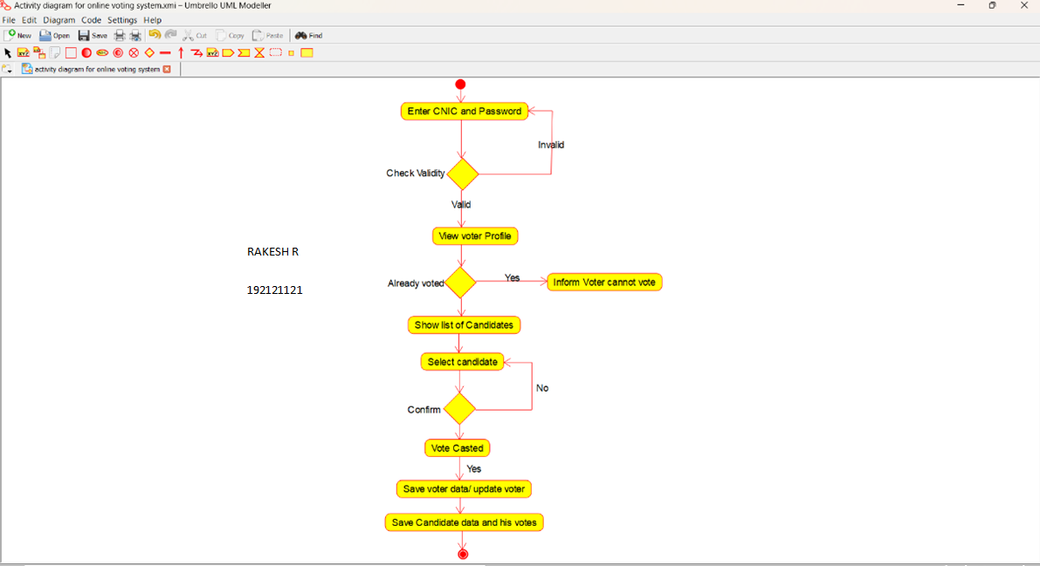

**16Q. Draw a Activity diagram for Library Management System using CASE tools.**

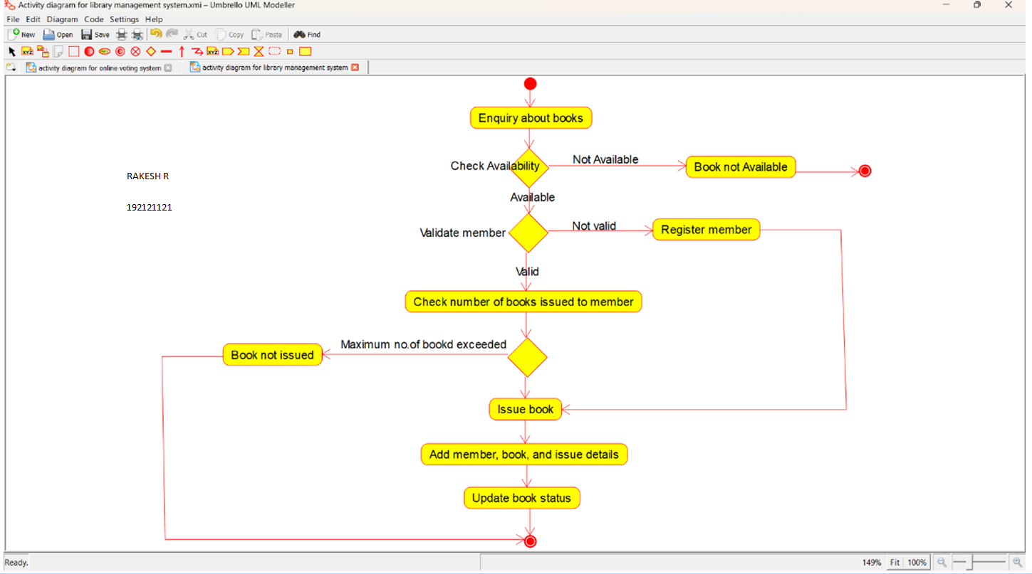

**17Q. Draw a Activity diagram for Online Shopping system using CASE tools.**

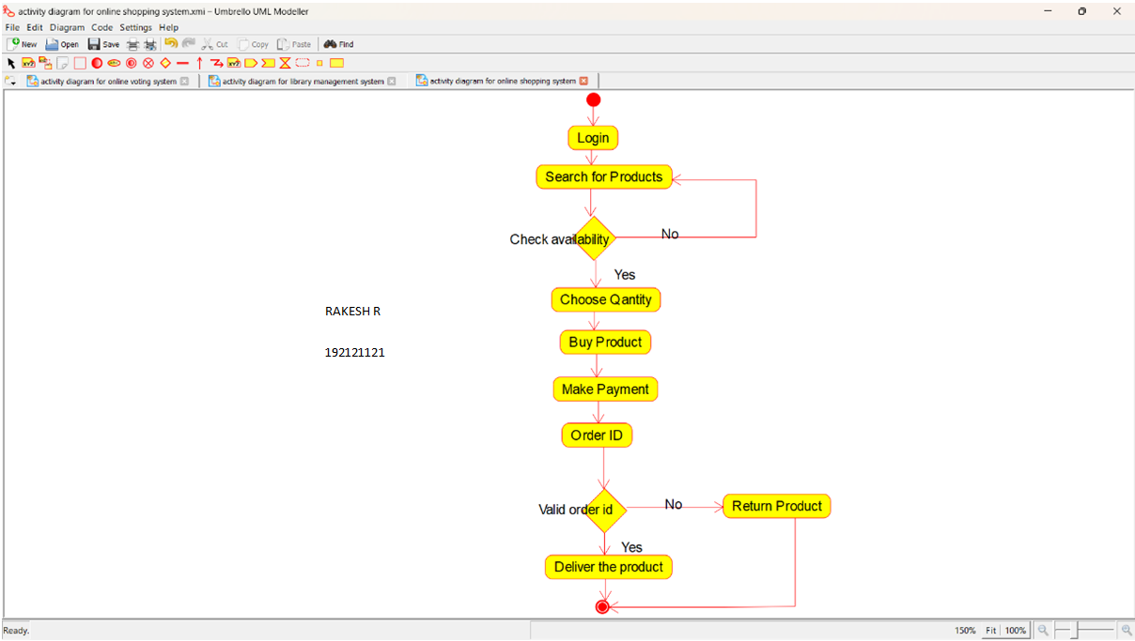

**18Q. Draw a Activity diagram for Online Railway Reservation System using CASE tools.**

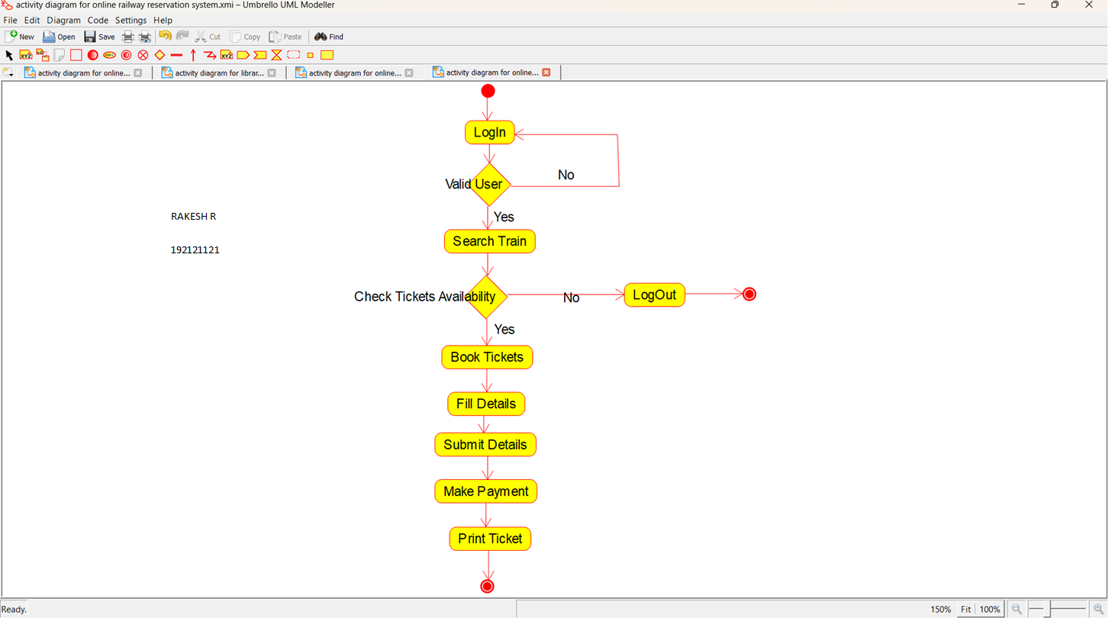

**19Q. Draw a Activity diagram for Hospital Management System using CASE tools.**

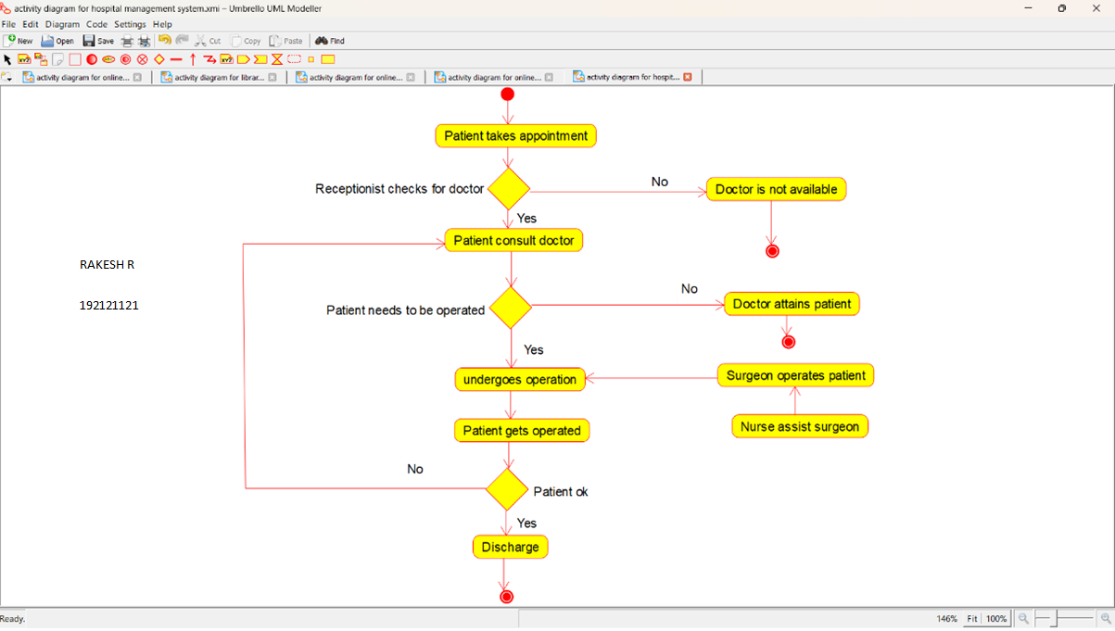

**20Q. Using Raptor- Draw the flowchart to check whether the given number is a palindrome or not.**

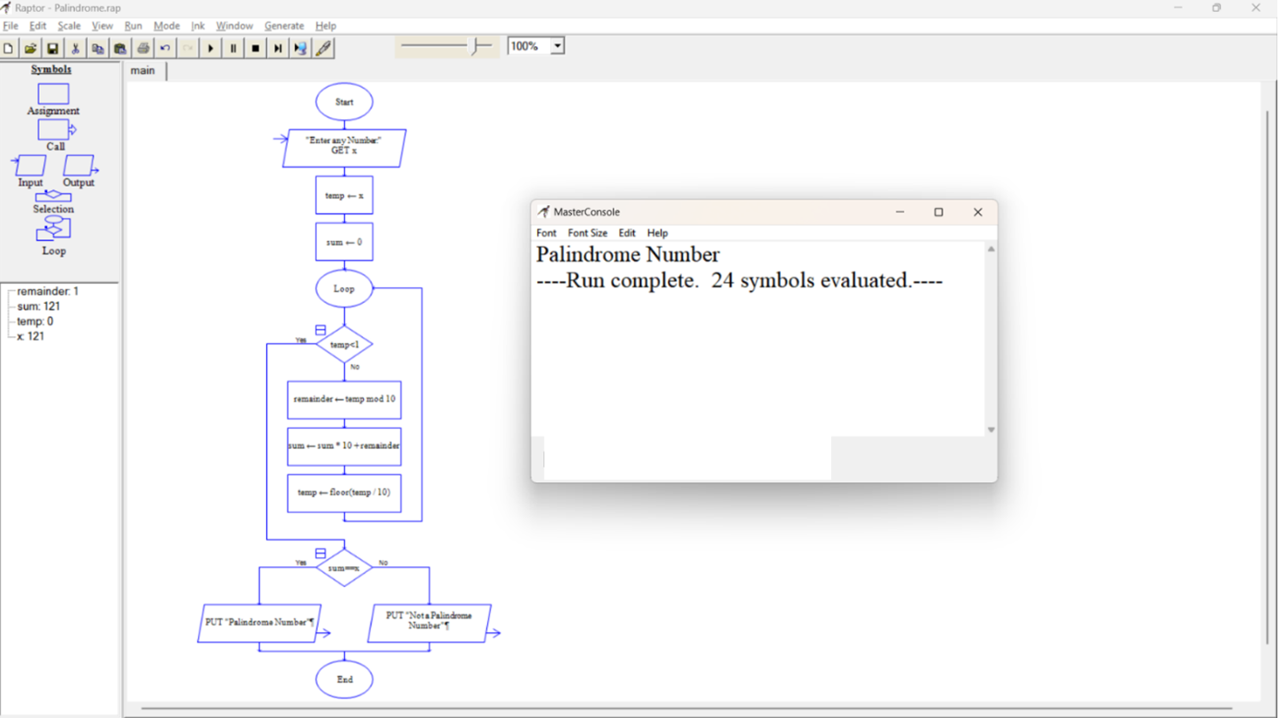

**21Q. Using Raptor- Draw and validate the flowchart to calculate Fibonacci series.**

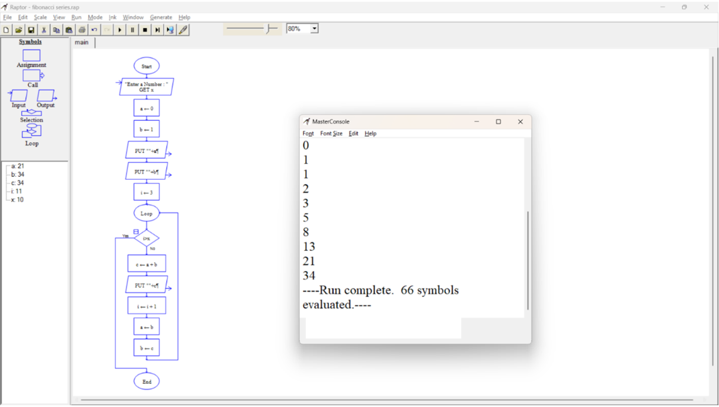

**22Q. Using Raptor - Draw and validate the flowchart to swap two characters.**

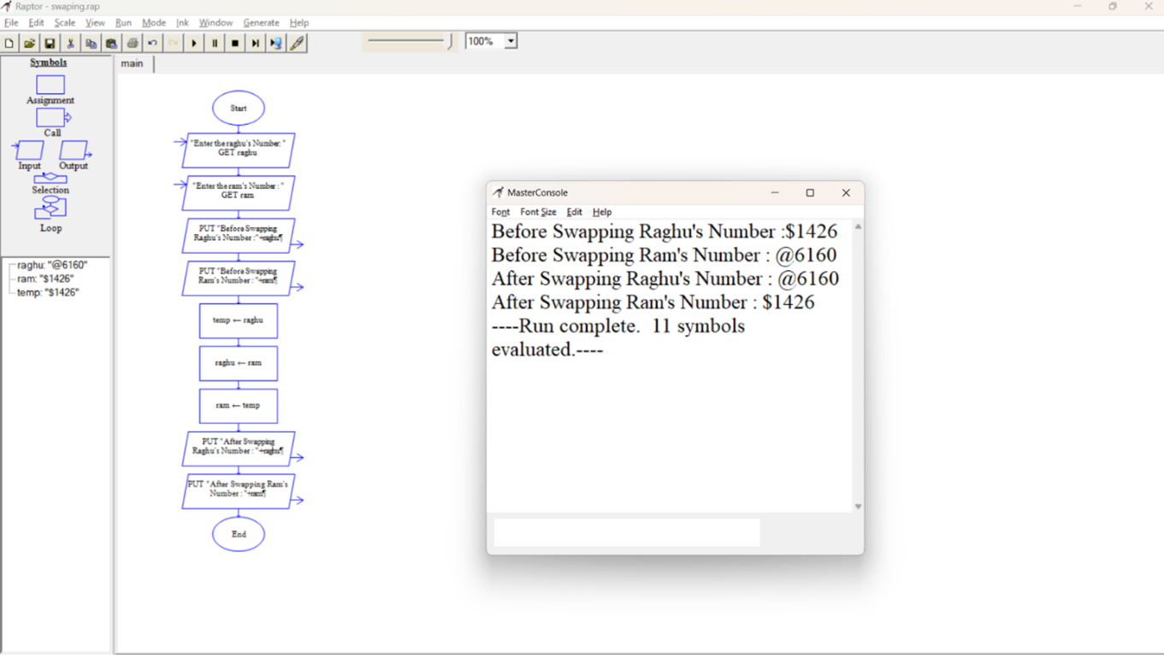

**23Q. Using Raptor - Draw the flowchart to display the length of the string.**

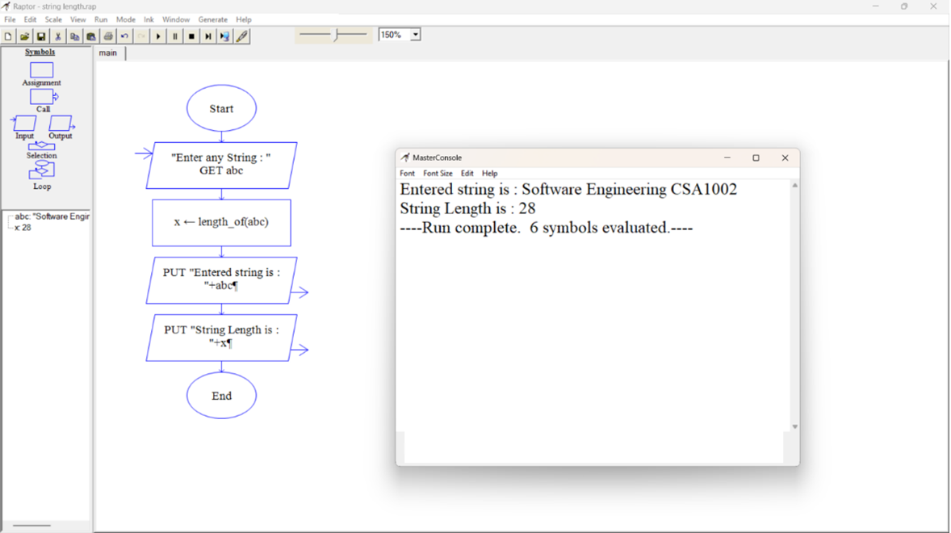

**24Q. Using Raptor - Draw the flowchart to find whether the given number is prime or not.**

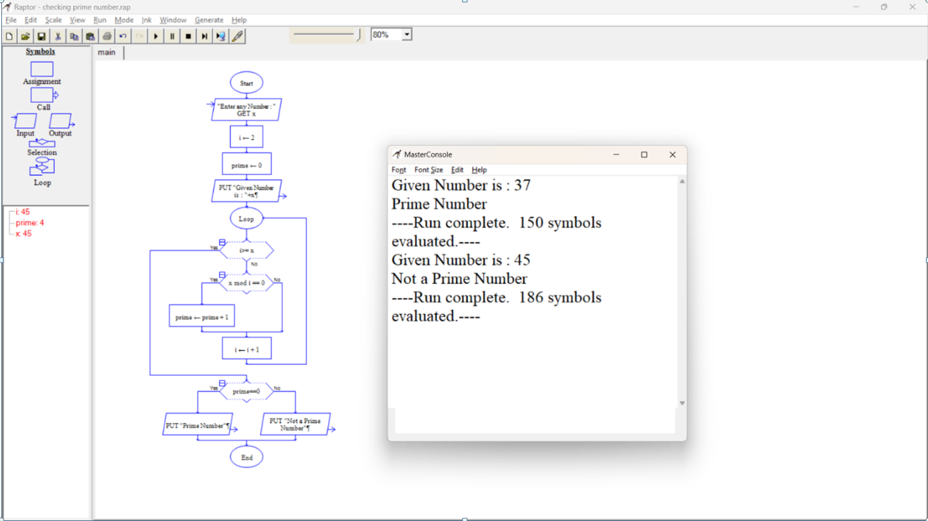

**25Q. Find Cyclomatic Complexity for a graph having number of edges as 17, number of nodes as 13 and number of predicate nodes in the flow graph as 5.**

